SHIELDING Guidance for families, with a Child on Home Ventilation –

After careful consideration ALL our families with a child on home ventilation are advised to follow shielding procedures from infection by Coronavirus 19 (COVID 19).

This document gives comprehensive and up-to-date links to that advice and guidance.
You will also find our contact details.

Your LTV team are meeting twice daily to share developments, prepare and act. Please keep us informed while you shield your family.

Please see robinhoodrespiratory.com for arrangements for an individual letter from us for employers.
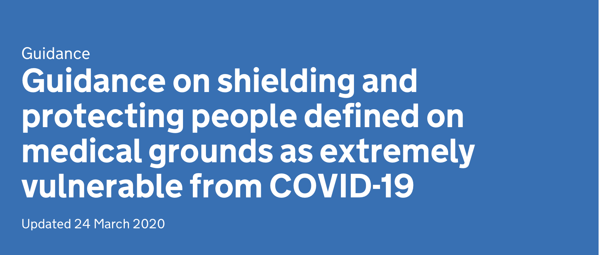

https://www.gov.uk/government/publications/guidance-on-shielding-and-protecting-extremely-vulnerable-persons-from-covid-19/guidance-on-shielding-and-protecting-extremely-vulnerable-persons-from-covid-19
The COVID 19 infection rate is rising rapidly at present and the national policy is to minimise spread of that virus.

SO PLEASE:
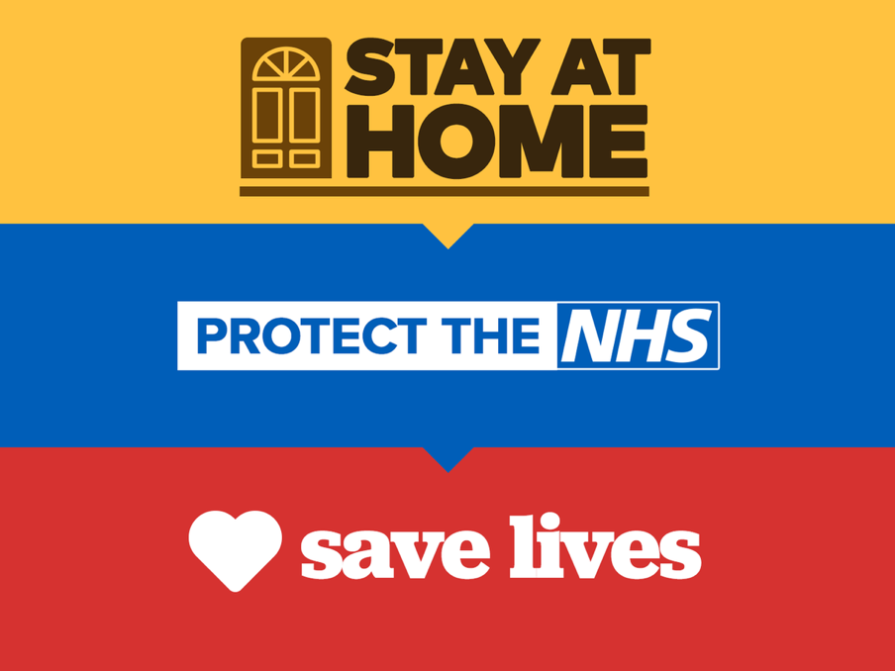

SHIELDING – of the whole family means no direct contact with others for 12 weeks which will substantially reduce the risk of you acquiring the infection.

Staying healthy whilst at home is important and guidance on this is available.

NOTTINGHAM CHILDREN’S HOSPITAL SHIELDING ADVICE:
Whilst the whole family are well –
no new continuous cough or fever (37.8ºC and above)
– strict handwashing, no facial touching and personal hygiene is essential. All should:
- Wash hands on arrival, before and after care.
- Use tissue or sleeve when sneezing or coughing
- Bin tissues then wash hands
- Wash hands on leaving
- Carers should stop attending if unwell



Link: NHS HANDWASHING VIDEO ABOVE
Link: NHS SHIELDING GUIDE BELOW
https://www.gov.uk/government/publications/guidance-on-shielding-and-protecting-extremely-vulnerable-persons-from-covid-19/guidance-on-shielding-and-protecting-extremely-vulnerable-persons-from-covid-19
If a child on home ventilation develops a new continuous cough or fever additional precautions are required:

TABLE 1: ACTIONS WHEN COVID 19 SUSPECTED

If a parent has a new continuous cough or fever they should isolate within the home and no longer provide direct care for the home ventilated child. This includes food preparation.

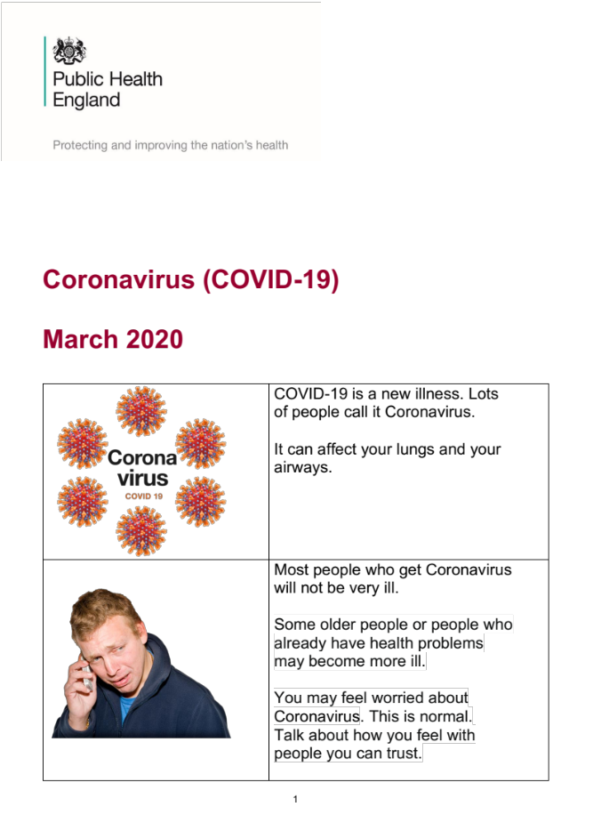

Link: PHE Stay at home guide
https://www.gov.uk/government/publications/covid-19-stay-at-home-guidance

GUIDANCE FOR CARERS

Carers attending healthy home ventilated families should follow strict personal hygiene.
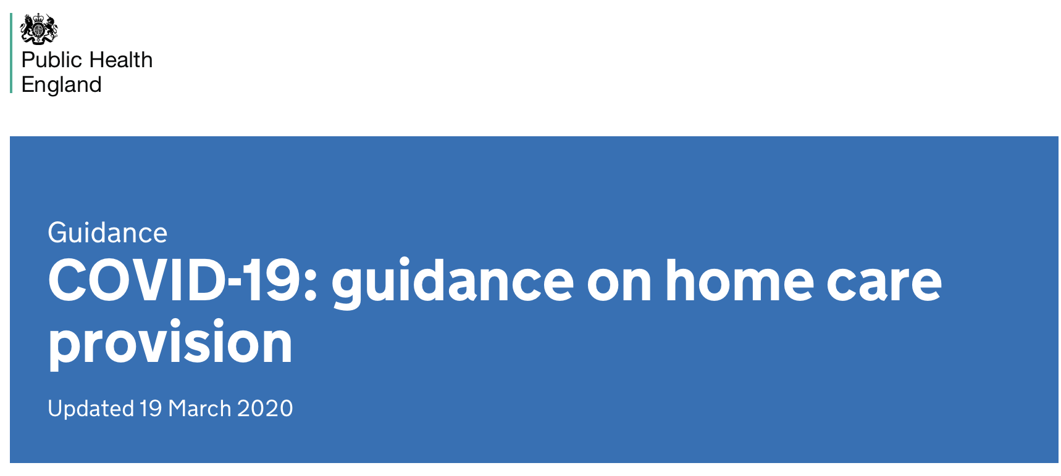
Link: Residential and Home care guidance:
https://www.gov.uk/government/publications/covid-19-residential-care-supported-living-and-home-care-guidance/covid-19-guidance-on-home-care-provision

Links: Wellchild guidance for care at home

https://www.wellchild.org.uk/2020/03/18/ten-ways-to-keep-my-child-with-complex-health-needs-safe/

https://www.wellchild.org.uk/2020/03/18/seven-rules-for-managing-carers-in-the-home/

New advice and guidance 26 March 2020

“ PPE to be used for all aerosol generating procedures “

Carers with a new continuous cough or fever

Should not work but should self-isolate and not attend the home/ventilated child.

Link: PHE Stay at home guide
https://www.gov.uk/government/publications/covid-19-stay-at-home-guidance

Carers attending home ventilated children who have cough or fever should use PPE and maintain strict personal hygiene which remains the most important action in minimising risk of acquiring infection.

Link to PPE for carers:
https://www.england.nhs.uk/coronavirus/wp-content/uploads/sites/52/2020/03/PPE-Letter-FINAL-20-March-2020-updated-on-22-March-2020.pdf

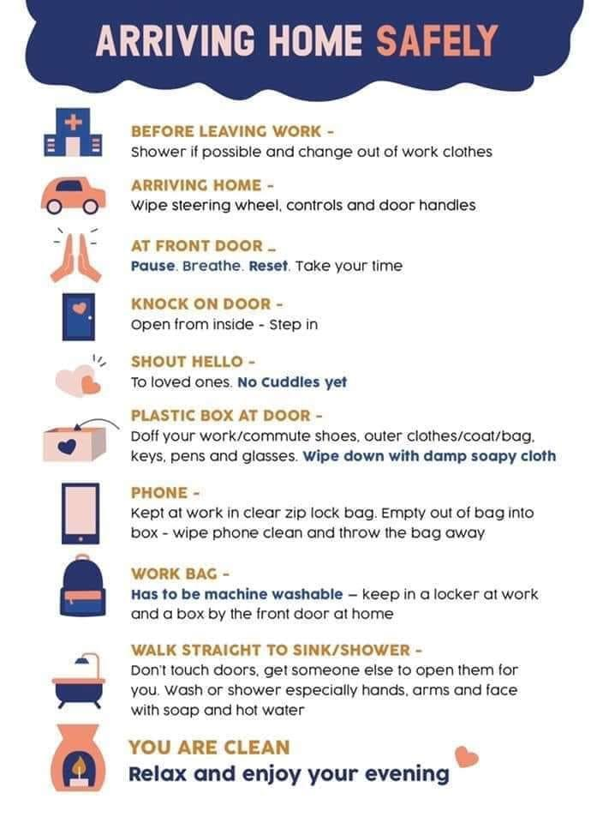

Links below: PHE Gov.UK relevant guidance
Stay at home

https://www.gov.uk/government/publications/covid-19-stay-at-home-guidance

Hand hygiene and hand control (no facial touching) remain the bedrock of infection control particularly when PPE is needed.

Barrier PHE and associated procedures

Link:
https://assets.publishing.service.gov.uk/government/uploads/system/uploads/attachment_data/file/874316/Infection_prevention_and_control_guidance_for_pandemic_coronavirus.pdf

Sources and advice re personal protection equipment
Links below

We await details of local hub location and contact details

https://www.england.nhs.uk/coronavirus/wp-content/uploads/sites/52/2020/03/PPE-Letter-FINAL-20-March-2020-updated-on-22-March-2020.pdf

https://www.england.nhs.uk/coronavirus/wp-content/uploads/sites/52/2020/03/PPE-Letter-FINAL-20-March-2020-updated-on-22-March-2020.pdf
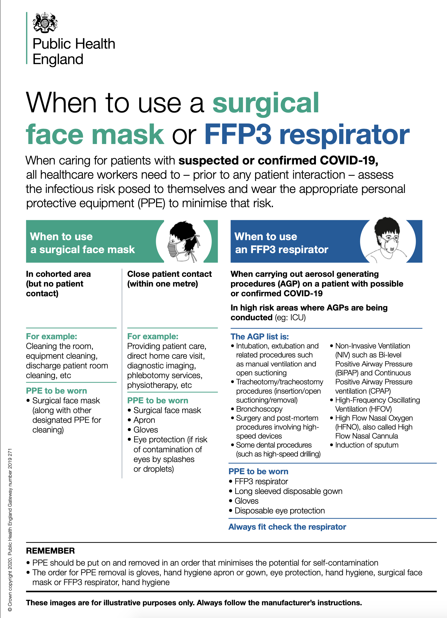
PHE PPE Respirator guidance

CONTACT US AT:

Email : LTVteam@nuh.nhs.uk

Telephone : 0115 9249924 ext :82207

Website : robinhoodrespiratory.com

Facebook: MyHomeVent Community developing –
lookout for new private group for mutual support

World Health Organisation & Public Health England
On Social distancing hand hygiene and touching
Link below:

https://www.gov.uk/government/publications/covid-19-guidance-on-social-distancing-and-for-vulnerable-people/guidance-on-social-distancing-for-everyone-in-the-uk-and-protecting-older-people-and-vulnerable-adults

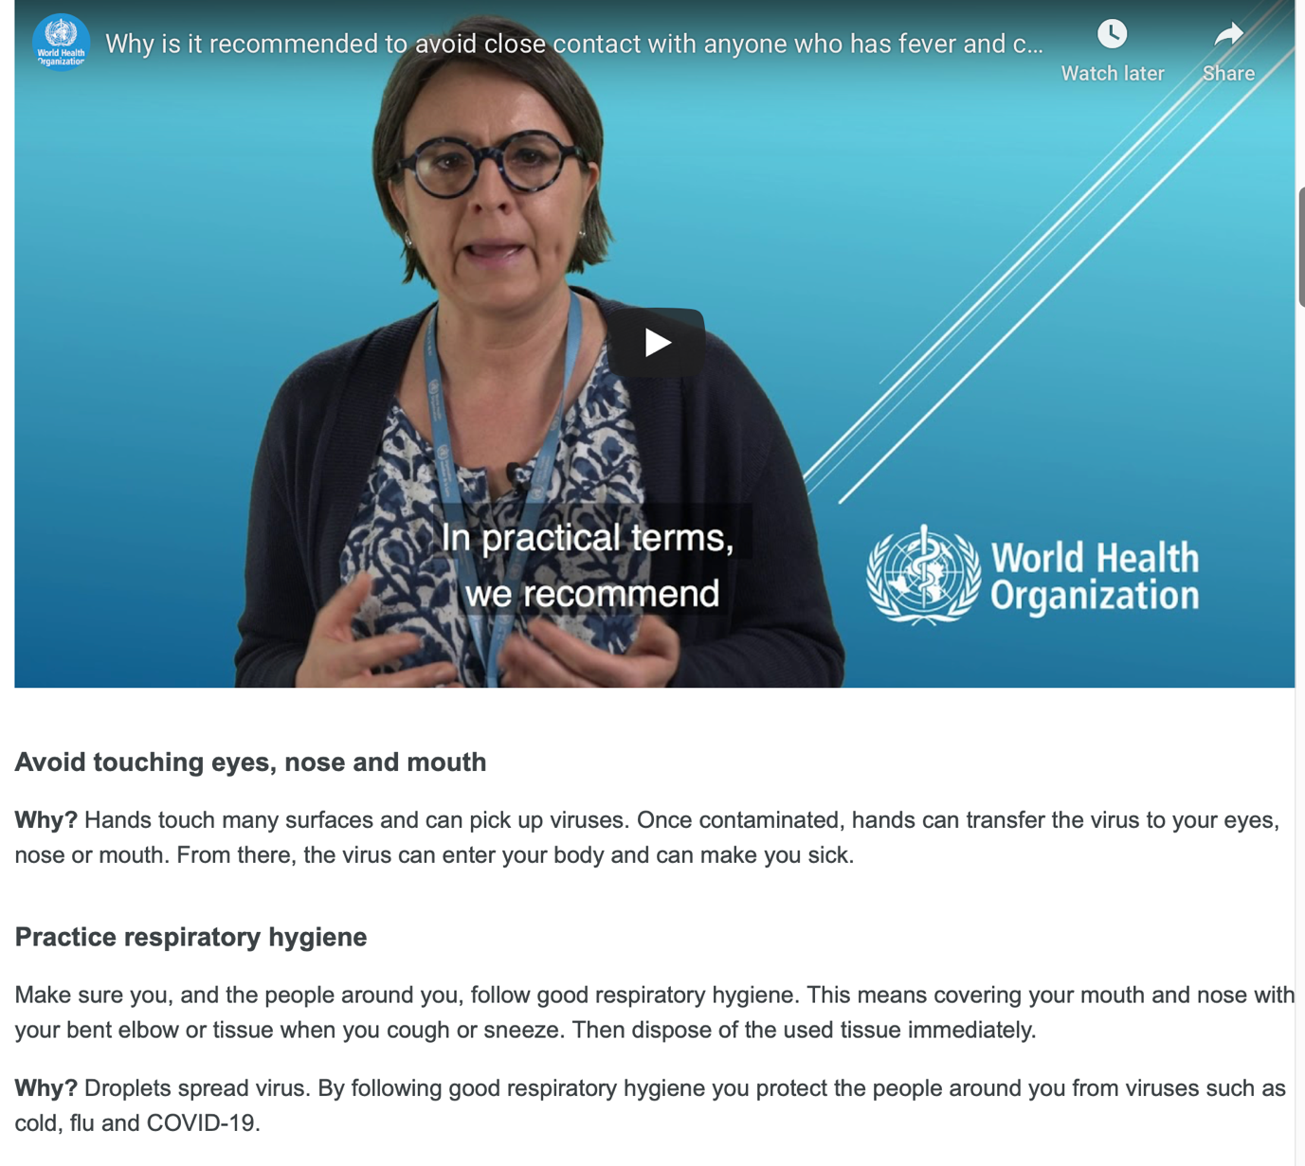
WHO Hygiene and Touching
Link: https://www.who.int/emergencies/diseases/novel-coronavirus-2019/advice-for-public

